# Instagram Content Planning Document

## Title Page

Account Name: smoothiebarinfusions

Date Created: 12/09/2025

| Title | Post Date | Time | Link | Notes | Hashtags | Type |
| --- | --- | --- | --- | --- | --- | --- |
| WIB | 12/13 | 11:00am |  | SL x PJ | #WillItBlend #SmoothieBar #DualTank #CannabisBlends #LAcannabis #StrainPairing #FlavorSpotlight | Post |
| The Student | 12/14 | 9:00am |  | Media exists | #smoothiebar #blend2 #whatsyourblend | Reel |
| Pier #2 | 12/15 | 10:00am |  | Lifestyle | #blend #smoothiebar #blend2 #whatsyourblend #santamonicapier | Post |
| SmoothiEdu | 12/16 | 1:00pm |  | Genetics | #Smoothiebar #blend2 #CannabisEducation #whatsyourblend | Post |
| WIB | 12/17 | 12:00pm |  | CL x ZU | #WillItBlend | Post |
| The Baller | 12/18 | 9:00am |  | Media exists | #smoothiebar #blend2 #whatsyourblend | Reel |
| Pier #3 | 12/19 | 11:00am |  | Lifestyle | #blend #smoothiebar #blend2 #whatsyourblend #santamonicapier | Post |
| SmoothiEdu | 12/20 | 5:00pm |  | Topic TBD | #Smoothiebar #blend2 #CannabisEducation #whatsyourblend | Post |
| WIB | 12/21 | 10:00am |  | Blend TBD | #WillItBlend | Post |
| Render | 12/22 | 10:00am |  | Flat | #smoothiebar #blend2 #whatsyourblend | Post |
| Lifestyle | 12/23 | 11:00am |  | Dropbox | #smoothiebar #blend2 #whatsyourblend | Post |
| Render | 12/24 | 8:00am |  | Fanned | #smoothiebar #blend2 #whatsyourblend#Xmaseve | Post |
| xmas theme render? | 12/25 | 8:00am |  | Boquet | #smoothiebar #blend2 #whatsyourblend#Xmas | Post |
| WIB | 12/26 | 11:00am |  | Blend TBD | #WillItBlend | Post |
| Smoothiedu | 12/27 | 5:00pm |  | Topic TBD | #Smoothiebar #blend2 #CannabisEducation #whatsyourblend | Post |
| Lifestyle | 12/28 | 10:00am |  | Dropbox | #smoothiebar #blend2 #whatsyourblend | Post |
| Render | 12/29 | 11:00am |  | Front Flat | #smoothiebar #blend2 #whatsyourblend | Post |
| Lifestyle | 12/30 | 9:00am |  | Dropbox | #smoothiebar #blend2 #whatsyourblend | Post |
| New Years | 12/31 | 8:00am |  | Dropbox | #smoothiebar #blend2 #whatsyourblend#NewYear | Post |

### 

### **Actual Draft Posts (Organized by Post Type)**

**Posts**

1. **Title: Santa Monica Pier Batch 1  
   Caption**: Wherever life may take you, Smoothie Bar will be there to make every experience just a bit brighter.

Nothing but good vibes and sunshine at the Santa Monica Pier!😎

**Hashtags**: [#blend](https://www.instagram.com/explore/tags/blend/) [#smoothiebar](https://www.instagram.com/explore/tags/smoothiebar/) [#blend2](https://www.instagram.com/explore/tags/blend2/) [#whatsyourblend](https://www.instagram.com/explore/tags/whatsyourblend/) [#santamonicapier](https://www.instagram.com/explore/tags/santamonicapier/)

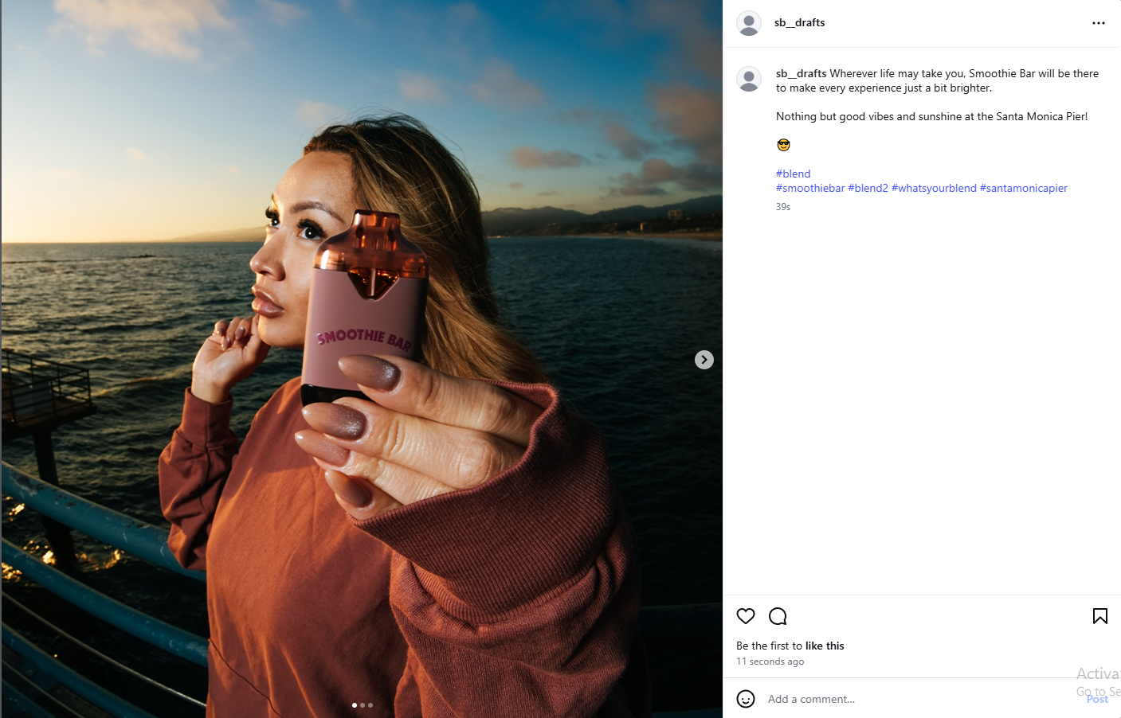

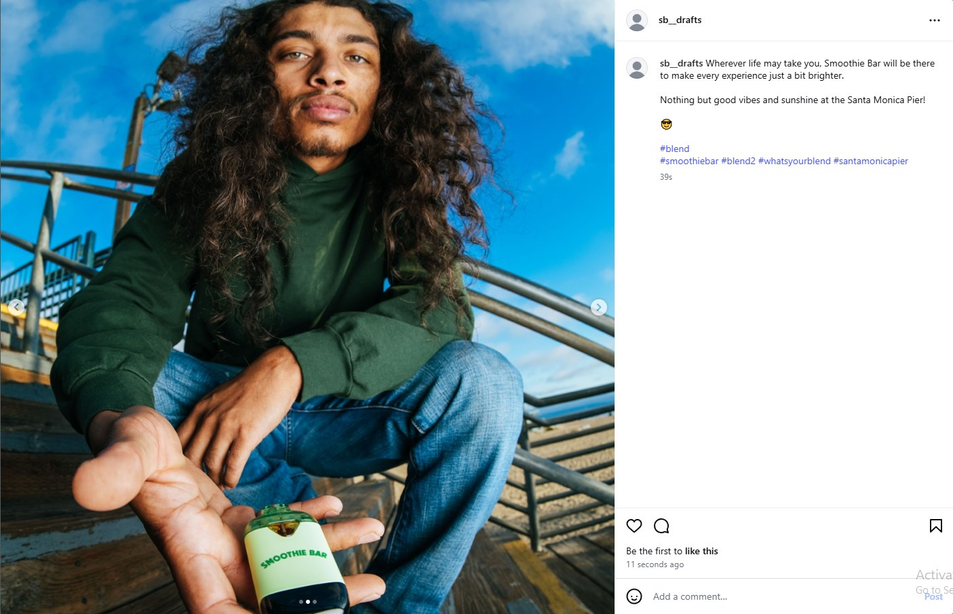

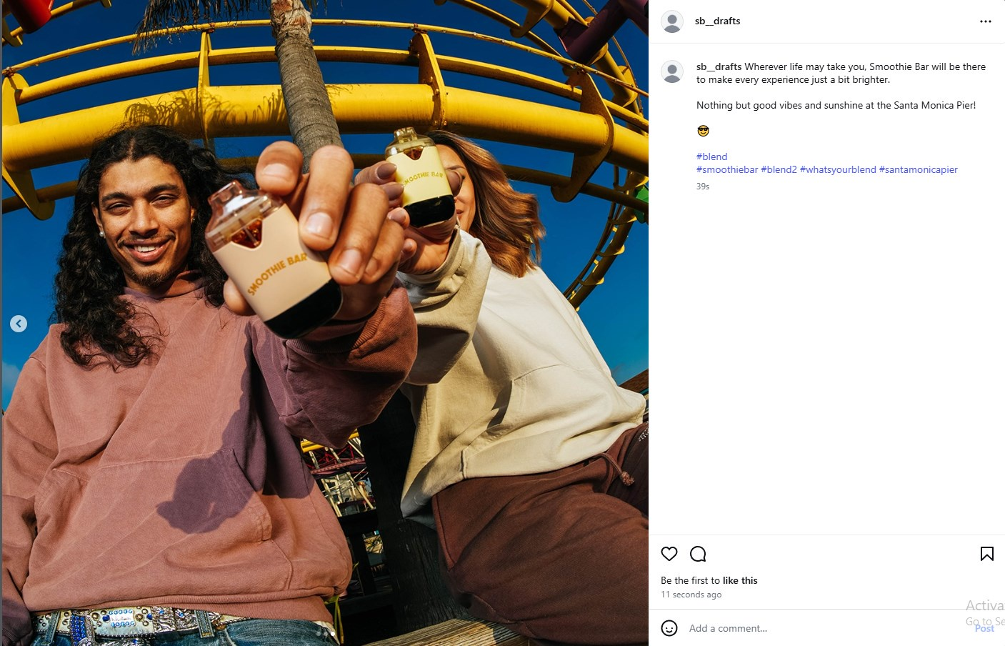

1. **Title: Santa Monica Pier Batch 2** **Caption**: We don't pass judgement, just the vape. 💯  
    **Hashtags**: [#blend](https://www.instagram.com/explore/tags/blend/) [#smoothiebar](https://www.instagram.com/explore/tags/smoothiebar/) [#blend2](https://www.instagram.com/explore/tags/blend2/) [#whatsyourblend](https://www.instagram.com/explore/tags/whatsyourblend/) [#santamonicapier](https://www.instagram.com/explore/tags/santamonicapier/)

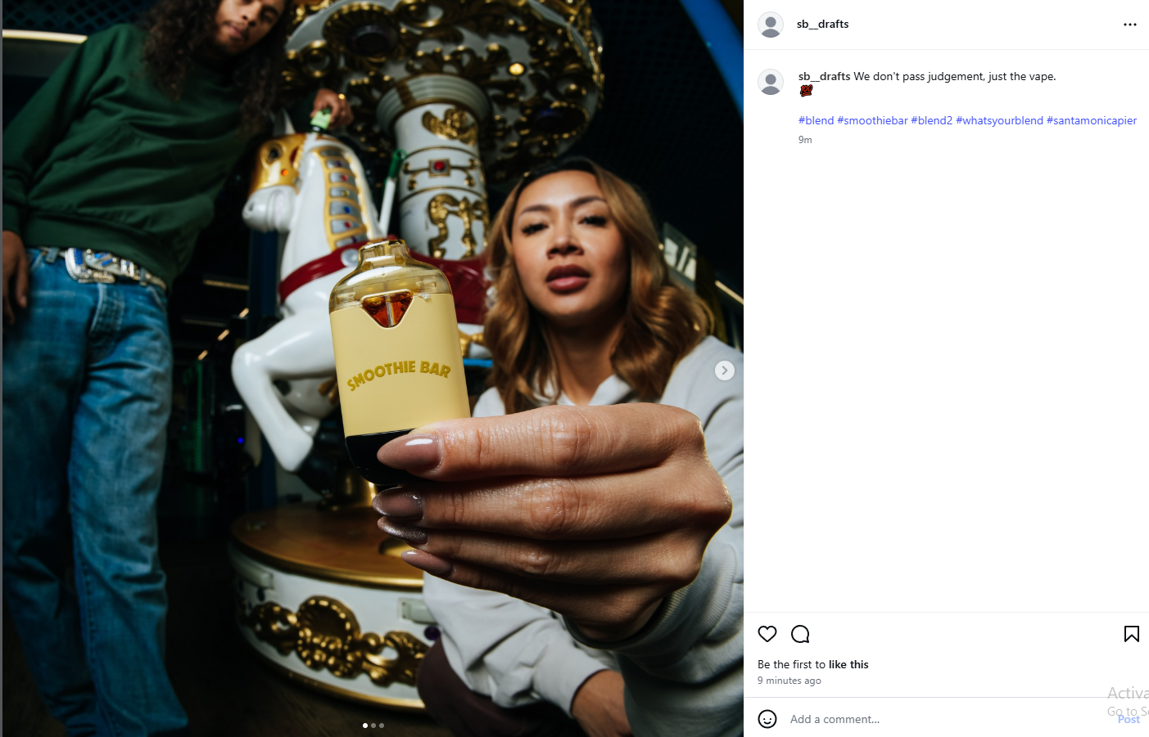

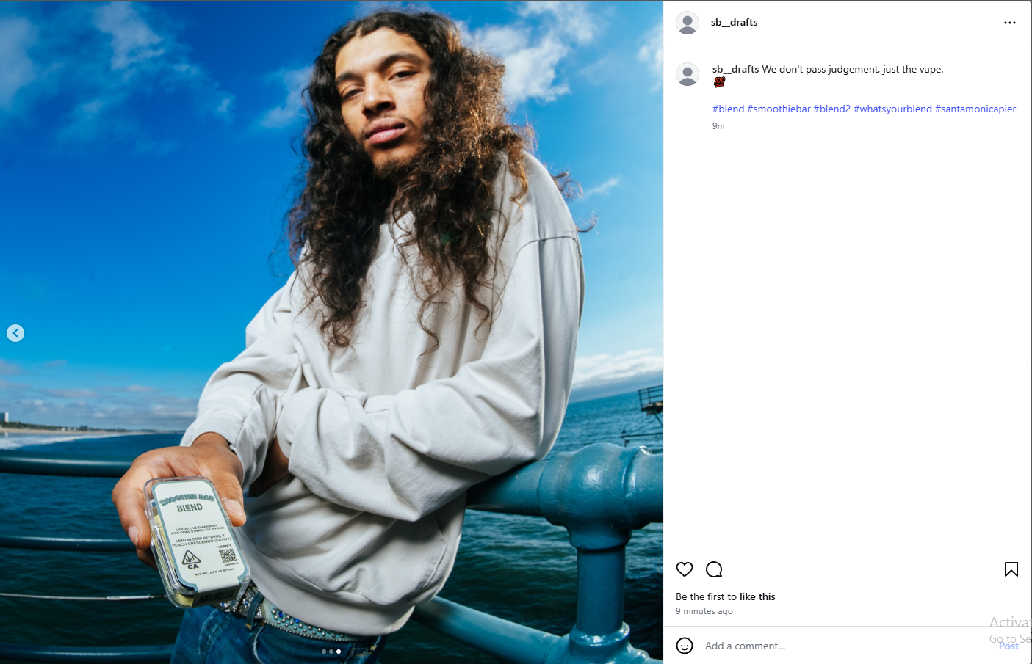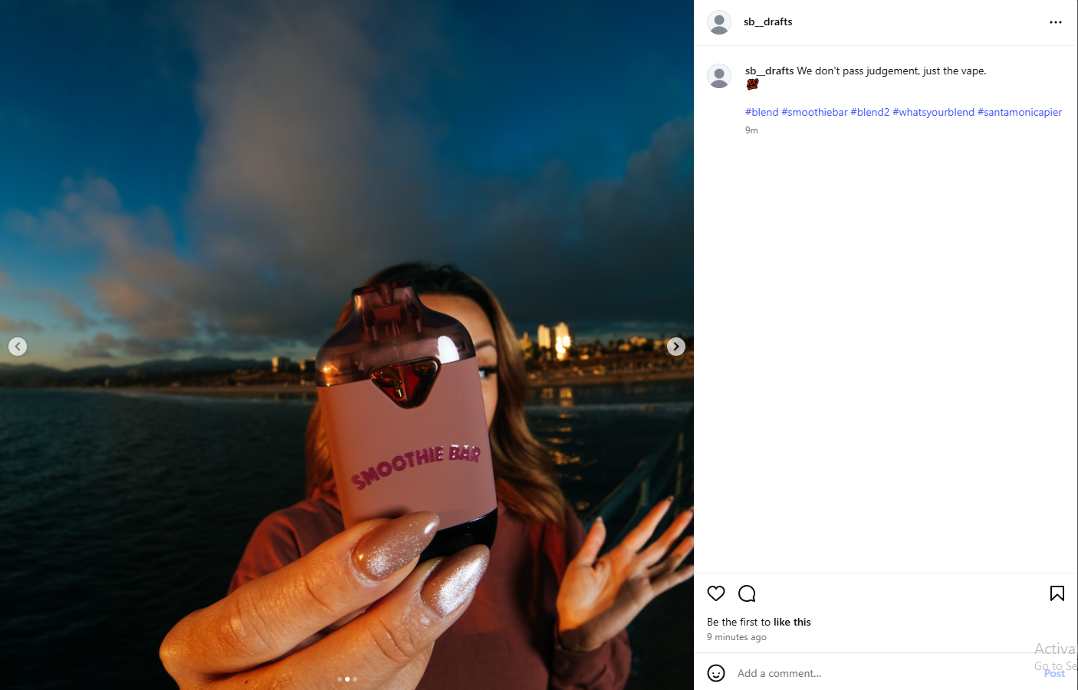

1. **Title: Santa Monica Pier Batch 3  
   Caption**: The sight of ocean waves, the sound of seagulls, and the taste of Smoothie Bar Blend. That's our idea of paradise! 👌 🌊🎡🌊  
   **Hashtags**: [#blend](https://www.instagram.com/explore/tags/blend/) [#smoothiebar](https://www.instagram.com/explore/tags/smoothiebar/) [#blend2](https://www.instagram.com/explore/tags/blend2/) [#whatsyourblend](https://www.instagram.com/explore/tags/whatsyourblend/) [#santamonicapier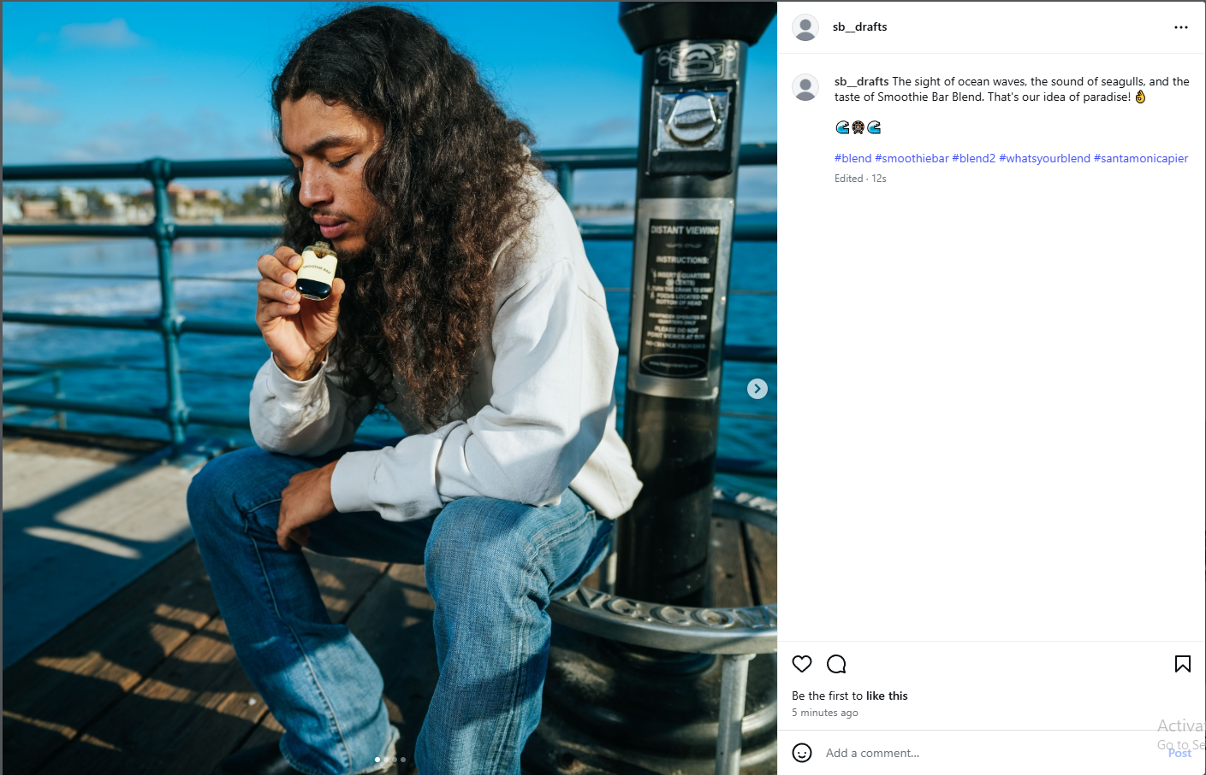](https://www.instagram.com/explore/tags/santamonicapier/)[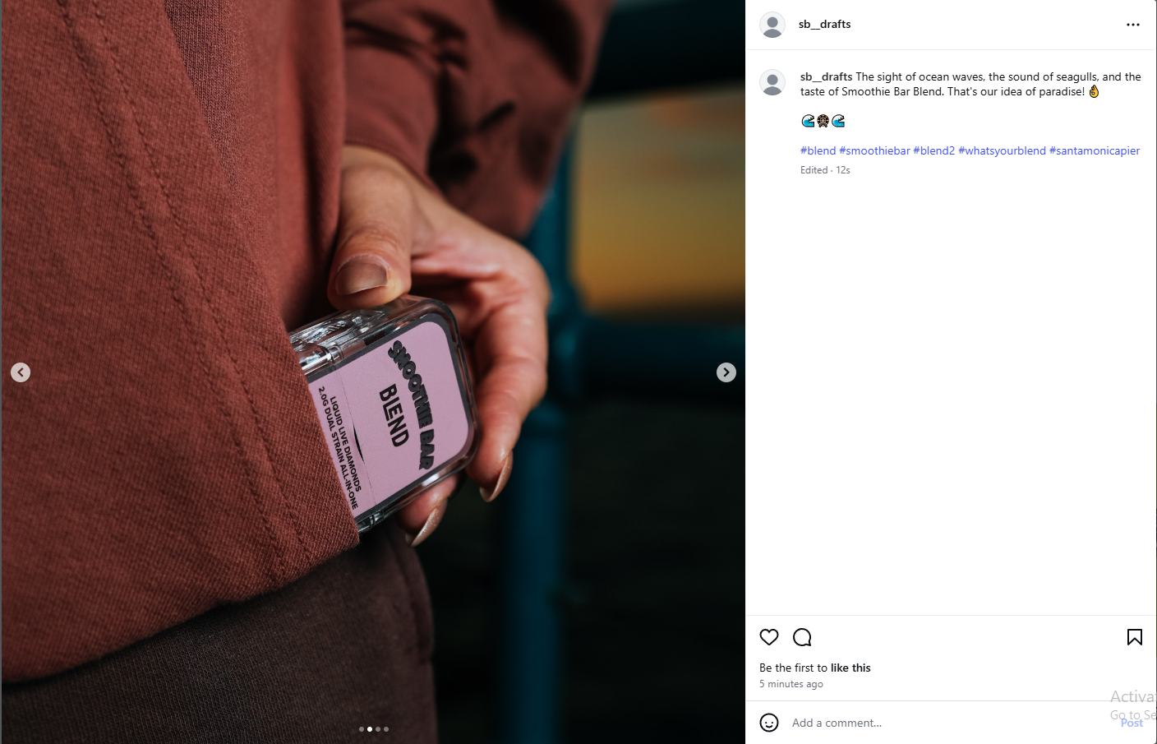](https://www.instagram.com/explore/tags/blend2/)

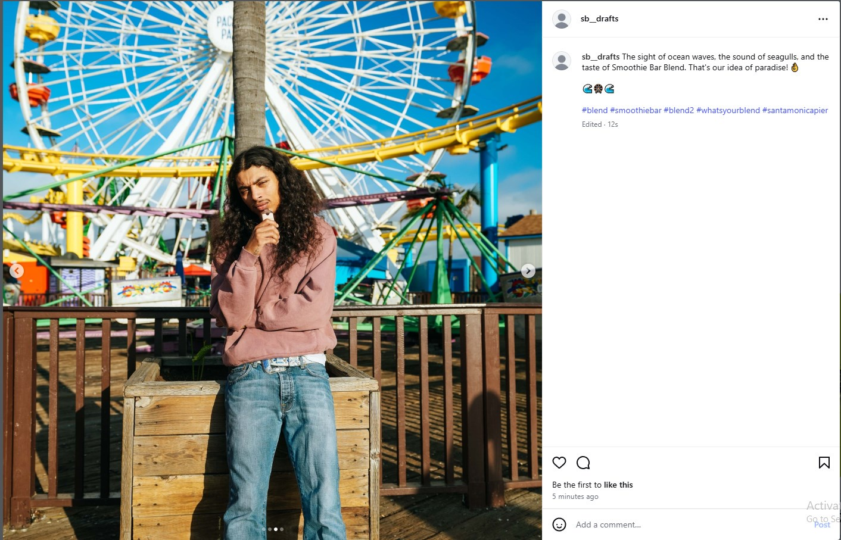

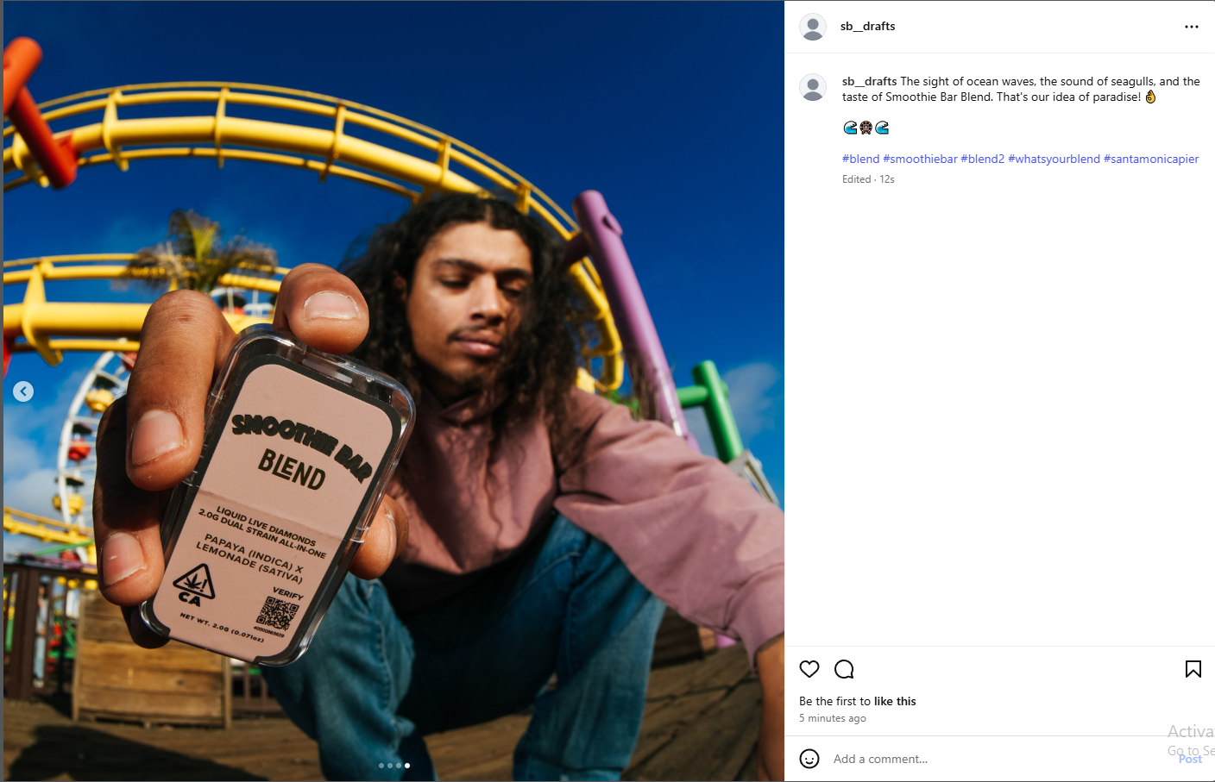

**Reels**

1. **Title:** Caption:  
    Embed Reel

**Highlights**

1. **Title:** Description:  
    Highlight cover image

## Stories Schedule

1. **Stories Table - Title/Post Date/Time/Link to Post Below/Notes/Interactive elements**

| Title | Post Date | Time | Link | Notes | Interaction |
| --- | --- | --- | --- | --- | --- |
| Educational | 12/13 | 8:00am |  | Safety/tutorial | Users will know their safety is considered |
| Behind Scenes | 12/14 | 8:00am |  | How it’s made | User is interested in process |
| Shoutout | 12/15 | 8:00am |  | Partners/workers | Exposed to product |
| Product Demo | 12/16 | 8:00am |  | Showcase | User sees device in action |
| Poll | 12/17 | 8:00am |  | Product or variant pref | User votes |
| Fun Facts | 12/18 | 8:00am |  | Lesser known facts | User learns unique info |
| Q&A | 12/19 | 8:00am |  | Answer questions live | User asks and shows knowledge |
| Customer Spotlight | 12/20 | 8:00am |  | Customer w/ product | Exposed to product |
| Lifestyle | 12/21 | 8:00am |  | Day in the life, laid back | Gives user vibe, relatable |
| Testimonial/UGC | 12/22 | 8:00am |  | Feedback | User hearing from other |

1. **Collage of stories photos to be used - vids to be used linked/embedded in doc**

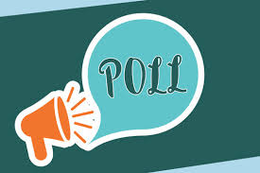 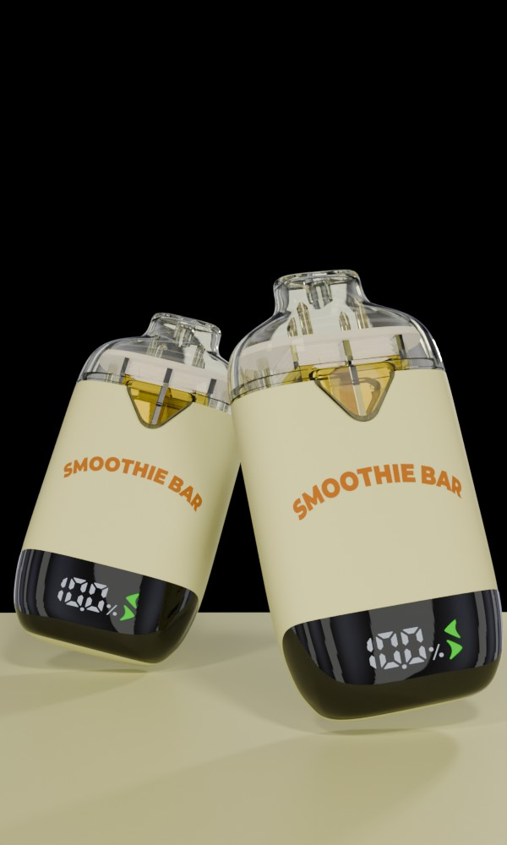

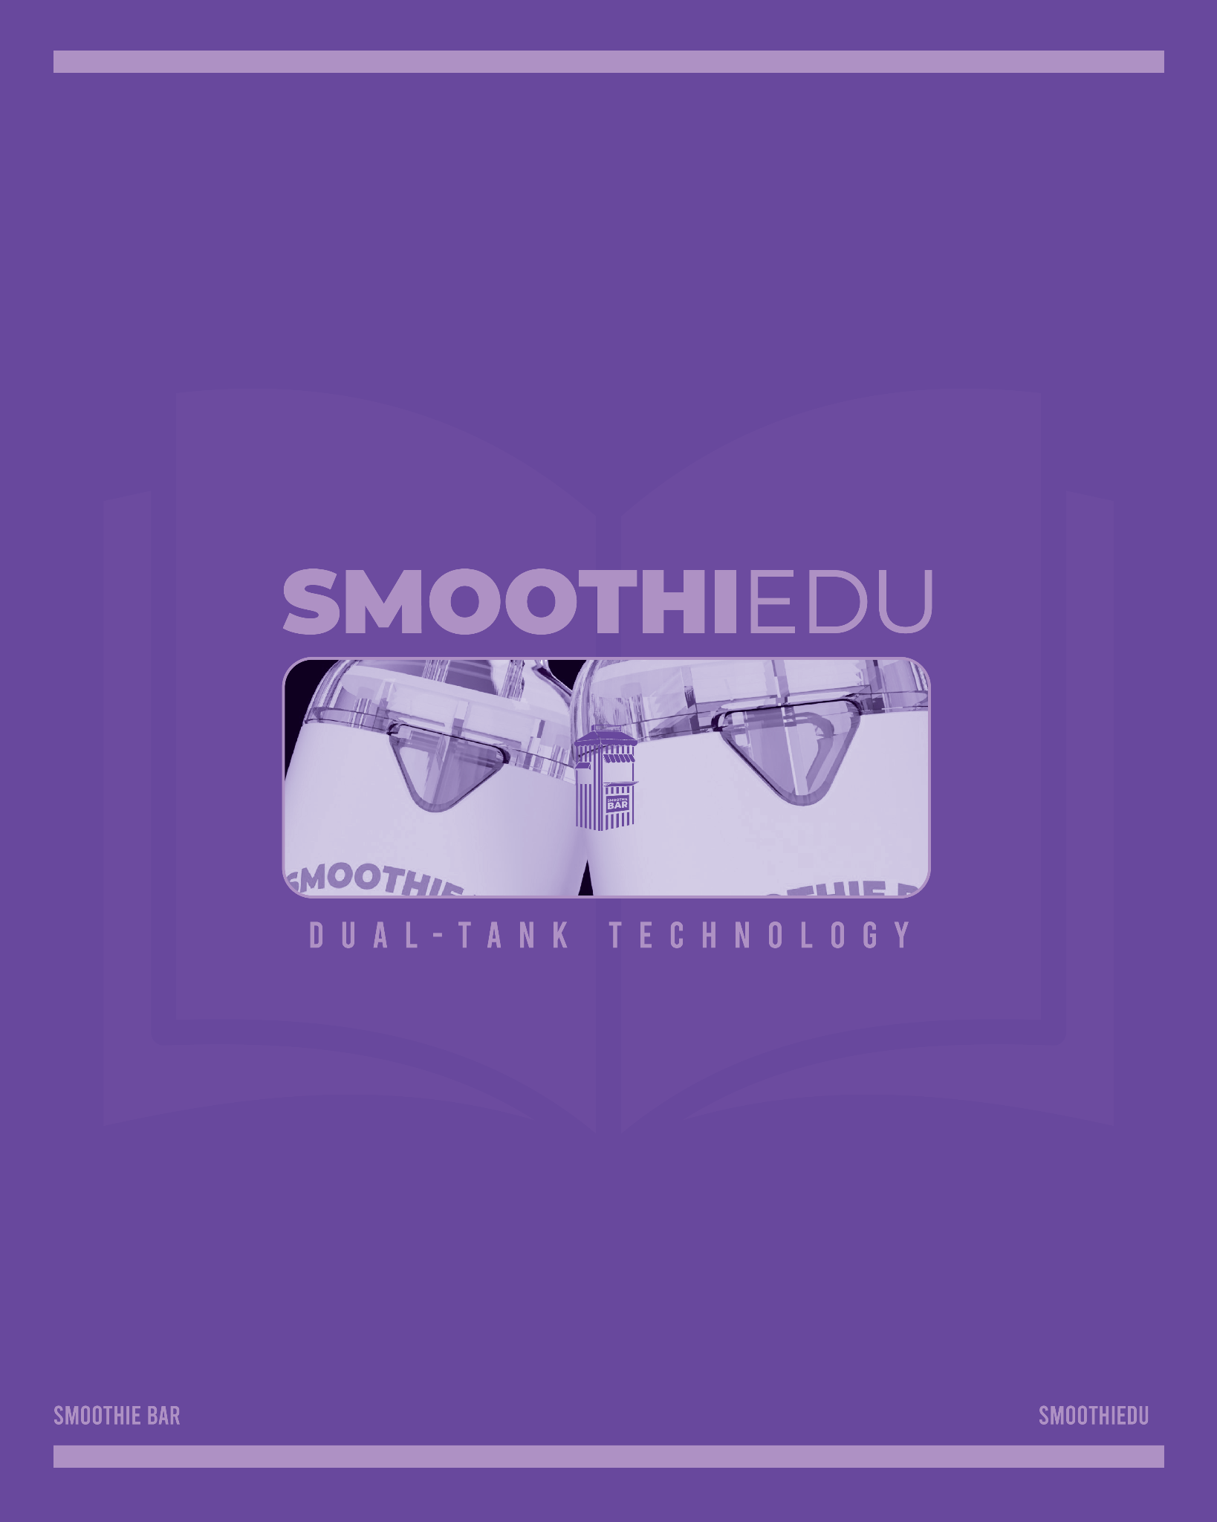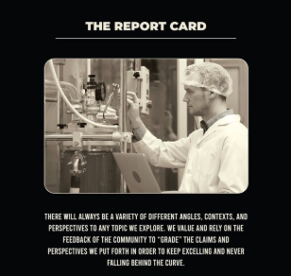

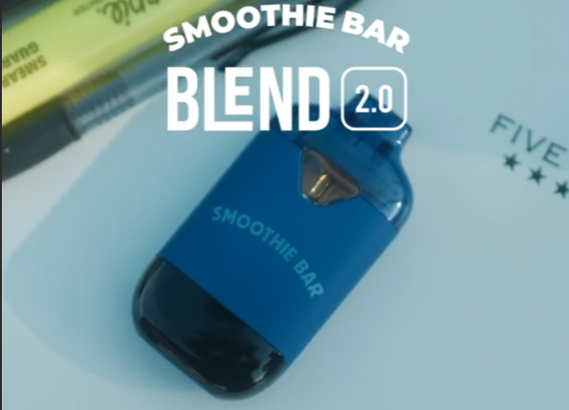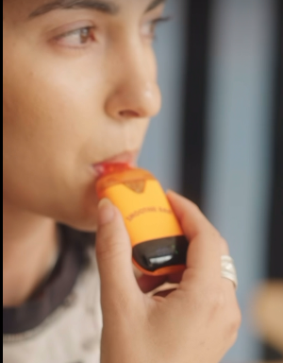

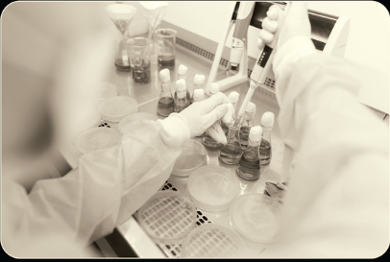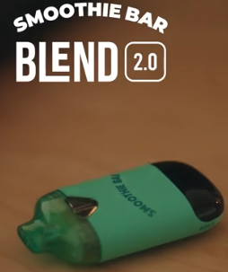

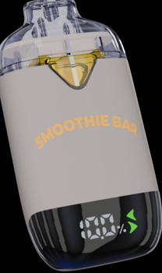 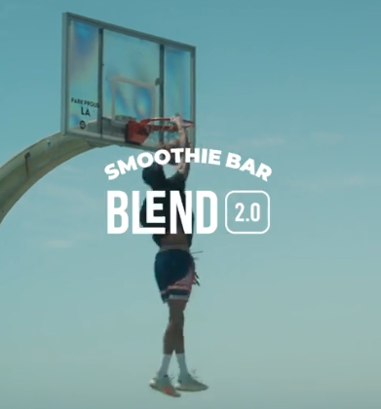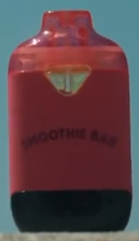

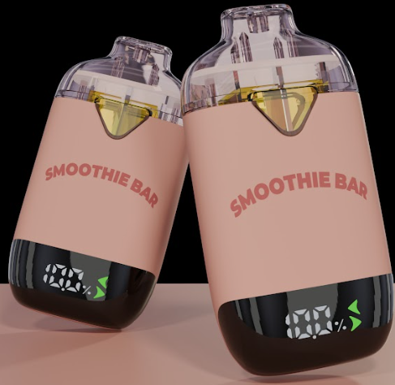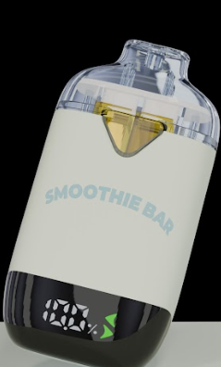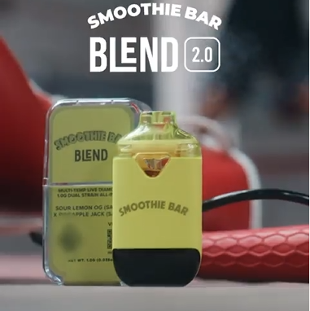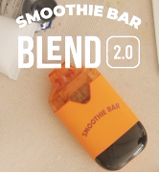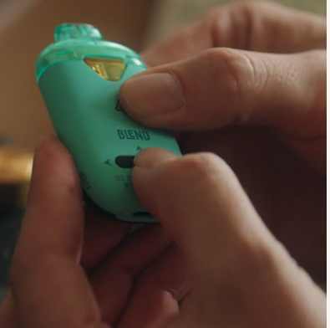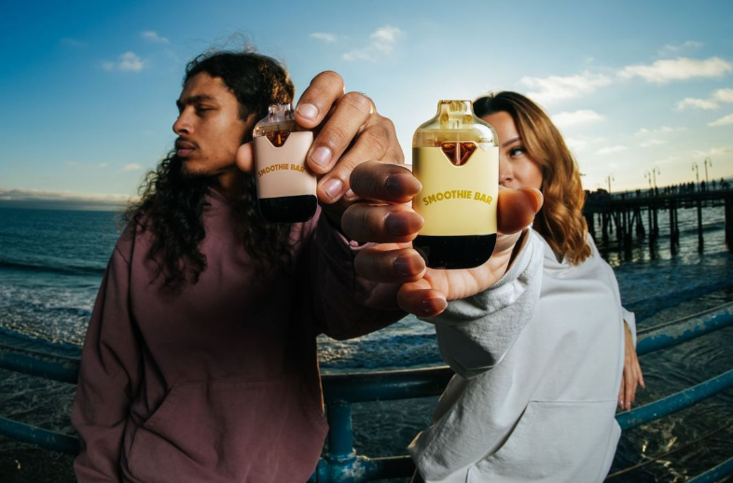

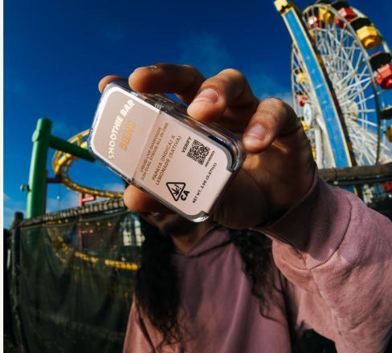

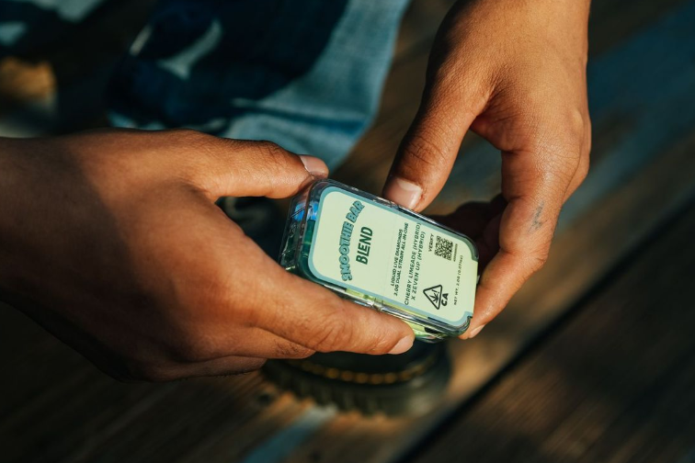

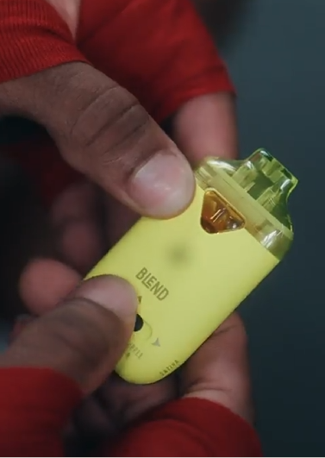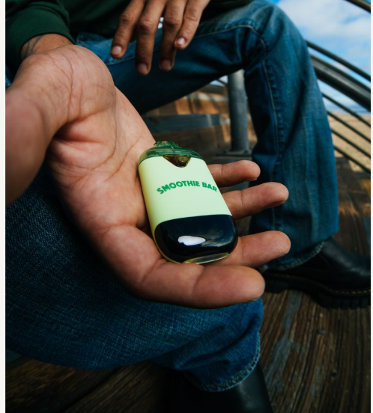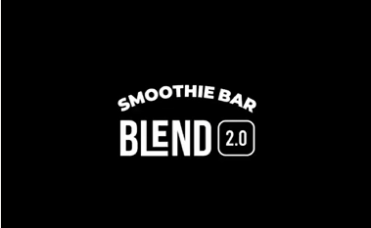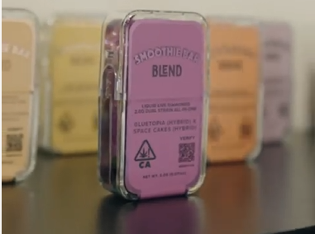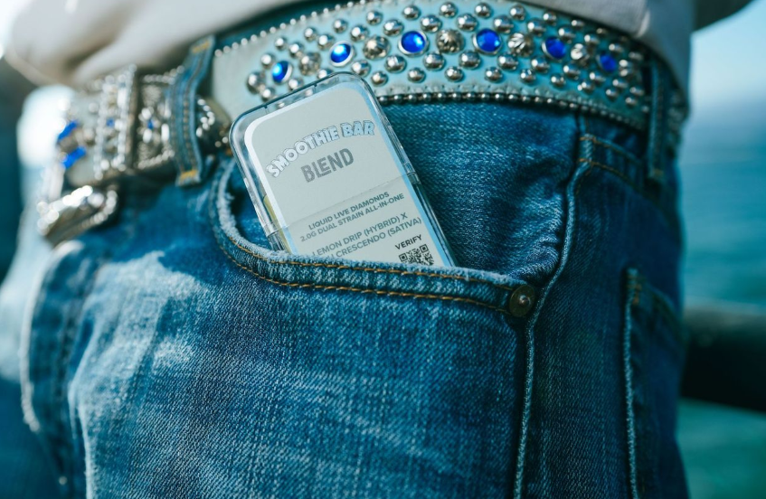

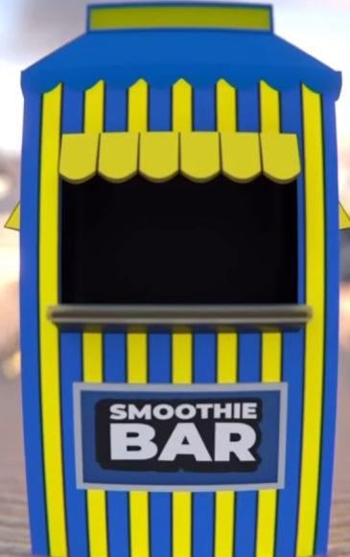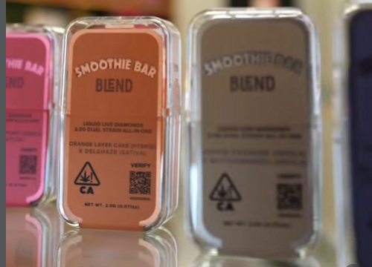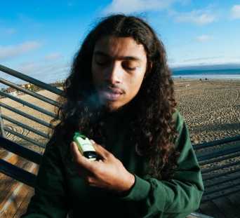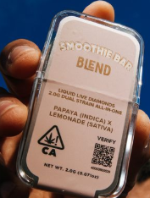

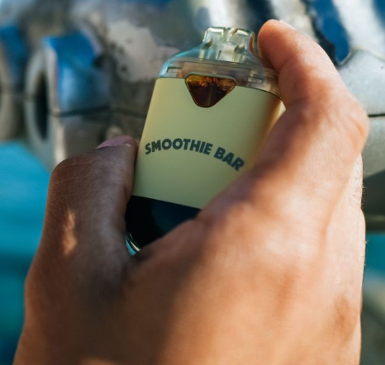

*Embed Links*

Account Interaction

1. Master list of accounts to interact with, amount of interactions planned per day, types of interactions (comments/likes, etc), easy way to “mark off” when interaction for the day has been completed (checklist?)

| Account Name | Interaction Type | Planned per day | Last Interaction | Completed? |
| --- | --- | --- | --- | --- |
|  |  |  |  |  |